User data API Design Documentation

**API**: /api/action/user_list/{apikey}

This API is designed to get the user data. In order to ensure the security of user data, the API only allows registered customers to access user data. We designed a simple and effective customer authorization scheme.

1. **Login Civicdata.com and query API Key.**

If you want to get CKAN user data, you must be logged into Civicdata.com and query the API Key which is the only credential for API calls.

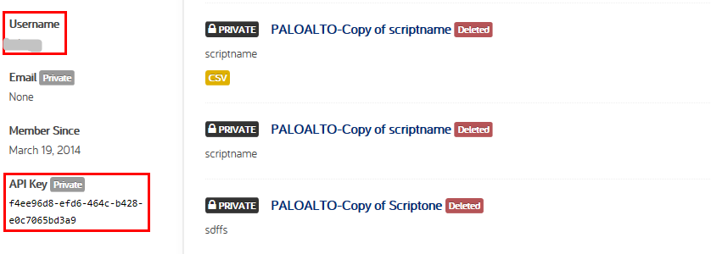

1. **Authorization**

API Key as a parameter for API, the server needs to verify the user’s credential (API Key) is valid. If passed will return the user data, otherwise it returns an error message.

1. **Get Data**

After authentication success, the API will return user data.

